K. J. Somaiya School of Engineering, Mumbai -77
(Somaiya Vidyavihar University)
Department of Science and Humanities
Course Name: | Basics Electrical  Engineering(BEE)  Course Code: 316U06C104 | Semester: | I
Exam: | BEE IA1(Simulation based  Assignment ) | Division: | All

Name: Siddhesh Sarode
Branch: IT-FY
Roll.No: 16010426069
Div-Batch: F-1
Course: BEE IA-1

Q1. Calculate the current through R1 Ω resistor using Mesh analysis. In the circuit shown in figure 1, the value of R1 will be the last two digits of roll no. times Ω
For e.g.: For Roll no: 1000020, then R1 = 20Ω. If your last digits are from 01 to 10, kindly add 10 to your last two digits, so roll no with last two digits with 01 will become 11, then R1 = 11Ω (ODD ROLL NO ATTEMPT Q1)
a) Simulate the circuit shown in figure 1, using LT spice software and measure I_{R1}, I_{4Ω} and I_{7Ω} and I_{3Ω}.
b) Also solve the numerical theoretically and calculate IR1, I4Ω and I7Ω and I3Ω.
Tabulate the results as shown in the table below.
Parameter | Theoretical value | Simulated value
I_{R1} | _{0.286A} | _{0.286A}
I_{4Ω} | _{3.468A} | _{3.468A}
I_{7Ω} | _{0.516A} | _{0.516A}
I_{3Ω} | _{3.238A} | _{3.238A}

BEE Semester: I Academic Year 2026-27
K. J. Somaiya School of Engineering, Mumbai -77
(Somaiya Vidyavihar University)
Department of Science and Humanities
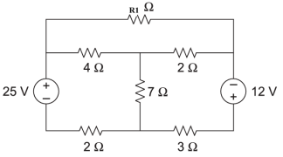 Figure 1

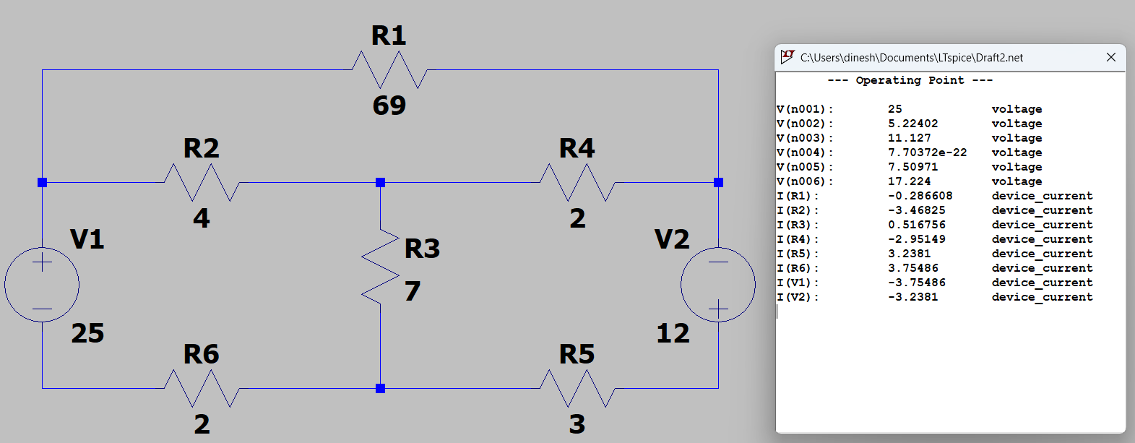

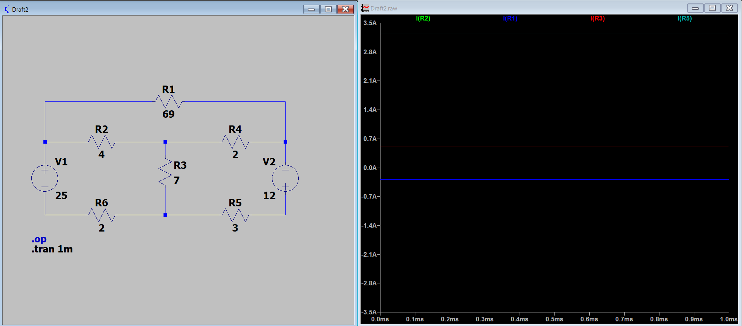
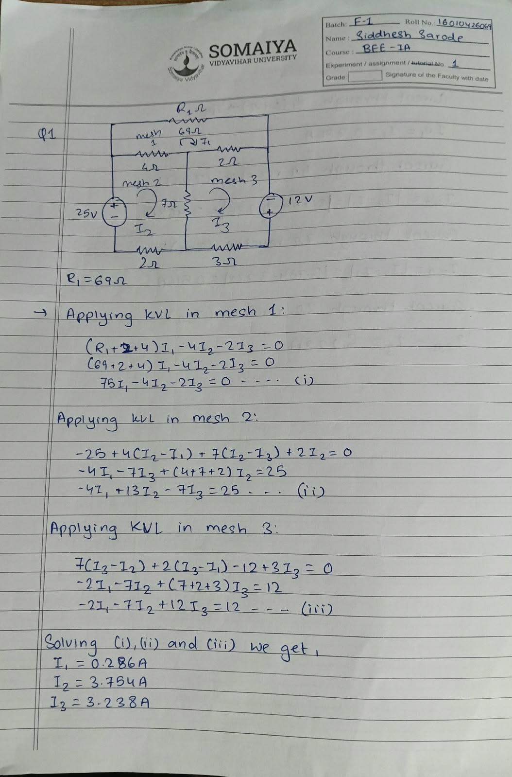

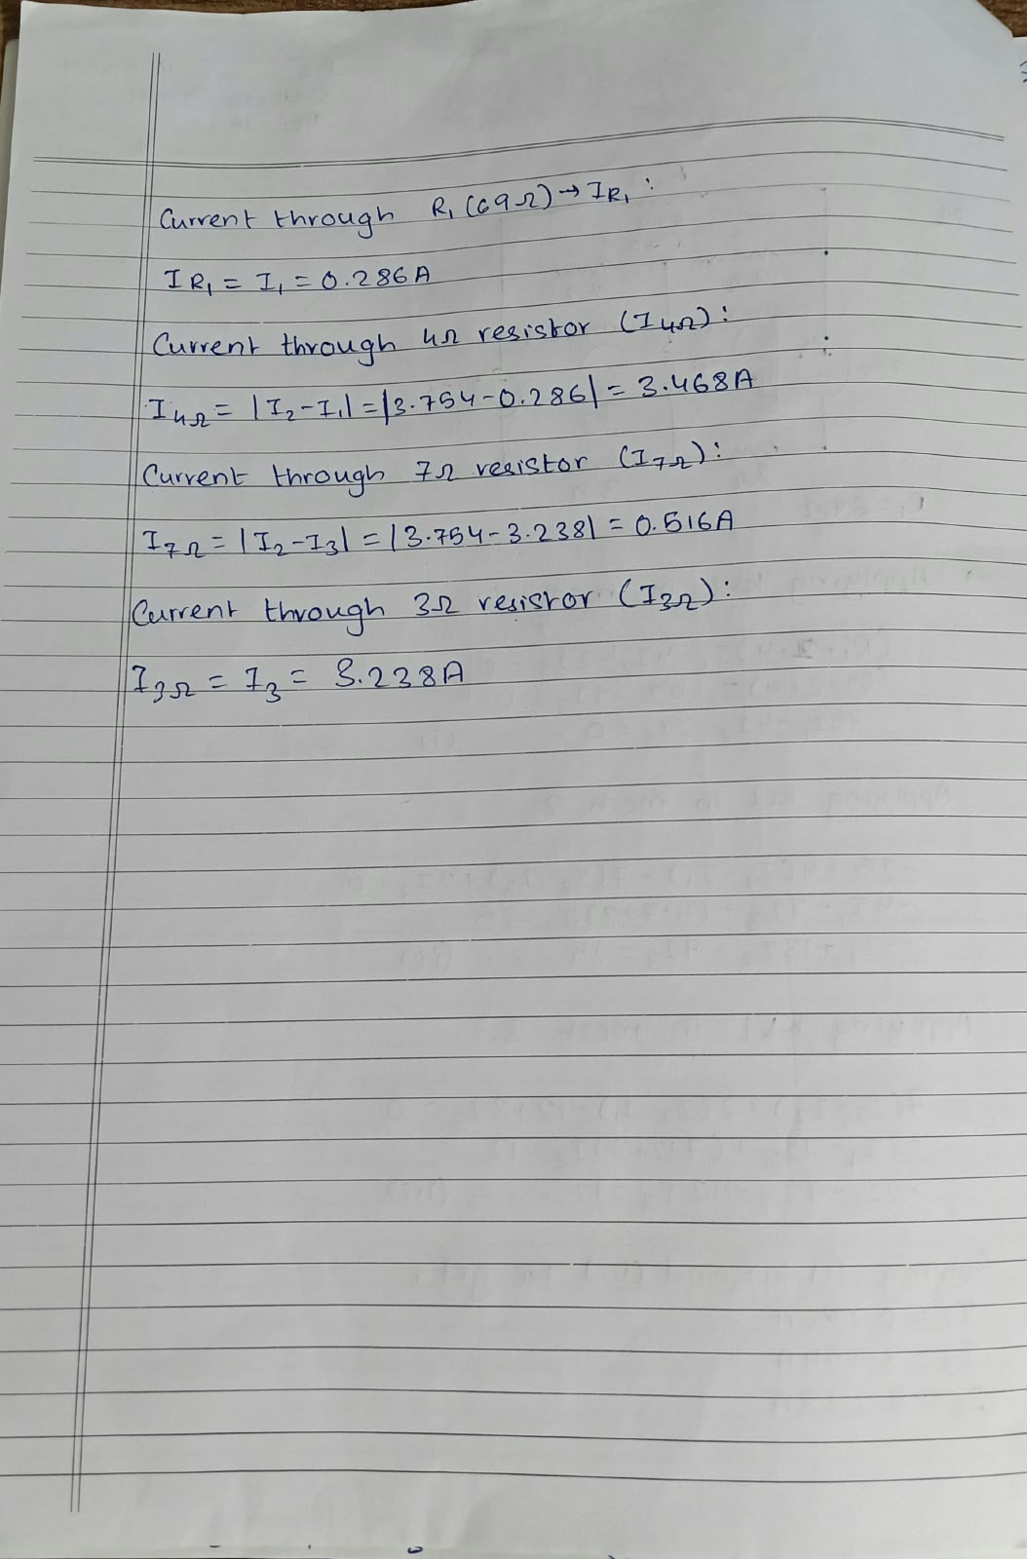

K. J. Somaiya School of Engineering, Mumbai -77
(Somaiya Vidyavihar University)
Department of Science and Humanities

